**Journal Report 9**

**10/20/23**

I am still awaiting a response from the NCNR as I don’t have access to their server currently. This was the error that I received:

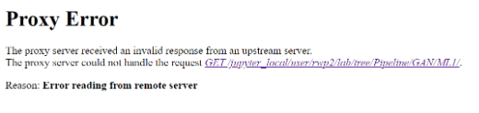

I was able to check how my GAN model performed on a Yahoo Dataset and it works relatively well. For some reason, my predictions and results are very noisy. The same problem happened over the summer when I was creating a forecasting model for my internship. I hope to decrease the amount of noise by applying Fourier transforms and hyperparameter tuning the GAN model. However, this is still a work in progress and might be the nature of the data itself.

Here is a picture of one of my predictions from GAN compared to the original stock data:

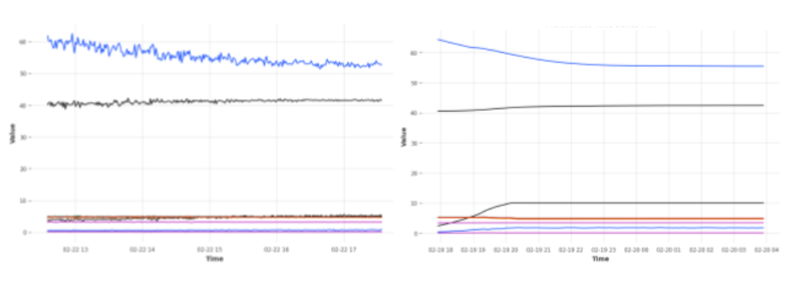

I worked on adapting this to my dataset by first analyzing the different attributes that could be manipulated for better prediction of other ones. My idea is to use this GAN model on my setpoint attribute first as multivariate may become too complex in the beginning. I deemed temperature and set point the most relevant variables.

**10/23/23**

I combed through my raw dataset and looked for any anomalous instances. I am hoping to create a supervised learning model to automate this process on the side. Currently, I have to manually graph and look at the data to see if any files seem anomalous. I did not find any during the class. The graphing process is accomplished through my Python script and shows a graph much like the ones shown above.

**10/25/23**

I discussed my next goals with Dr. Gabor. As I have received a new dataset, I have run my semi-automatic processing script. It took approximately 7 hours to preprocess one file and the dataset consists of 30 files. I am constantly running it on the NCNR server. I hope to complete this in two weeks. Afterward, I will implement a GAN model with this new data. I should be able to overlay this predicted data on the original one to check its performance.

After discussing my goals, I further analyzed my dataset. I continued to graph and check for any anomalies with the 40 minutes I had left.

This is a graph of the anomalous experiment that I found while analyzing my dataset. As you can see, Sensor C seems to dip all of a sudden and there seems to be a slight increase for Sensor B at noon. I think that this might have been some kind of electrical or wiring issue because it jumps immediately back up. I marked this as anomalous within a log and am trying to actively create a dataset with labels for both organization and future implementation.

